

**J. DARRELL BIRMINGHAM F.O.P. LODGE #140**

**11345 Blachleyville Rd**

**Wooster OH 44691**

**PH (440) 864-7904**

**OhioFOP140@fop.net**

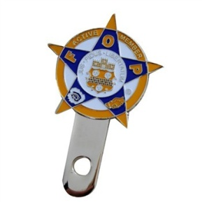 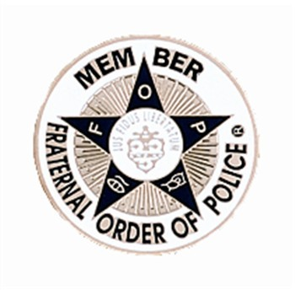 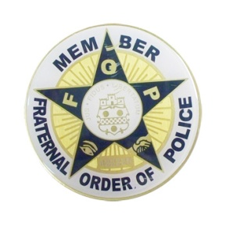 [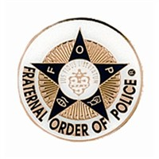](http://www.mylogogear.com/shop/store/20091217003/items/largeimages/F282_LARGE.jpg)

**License Plate Bolt-on * 1-5/8” Member Metal * 3” Active Metal * 1-5/8” Non - Member**

**$14.00 Adhesive Emblem Adhesive Emblem Adhesive Emblem**

**$5.50 $6.75 $5.50**

**⁮Quantity ⁮Quantity ⁮Quantity ⁮Quantity**

**ADD $5.00 Shipping/Handling (unless other arrangements are made for delivery)**

**Total Due $ ______________**

**Make Checks payable to: FOP Lodge 140**

**\*These Emblems are for FOP Members only - not to be used by friends or family.**

**Member Name _________________________________________________________**

**FOP Member Number ___________________________________________________**

**Address _______________________________________________________________**

**_______________________________________________________________**

**Phone _________________________________________________________________**

**License Plate Numbers (Emblems will be used on)**

**______________________________**

**______________________________**

______________________________

______________________________

**If you have any questions, you may call, write, or send an E-Mail to:**

Lisa Barnett

11345 Blachleyville Rd

Wooster OH 44691

PH (440) 864-7904

**E-Mail:** OhioFOP140@fop.net

* NOTE : Individually numbered items that are recorded by the Lodge.